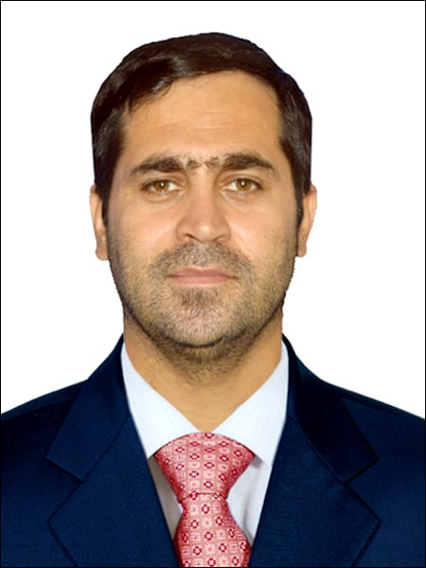Prof. Dr. Dildar Muhammad

Professor of Nursing &

Dean Faculty of Nursing Sciences

Khyber Medical University Phase-V, Hayatabad Peshawar

Mob: 0092-301-2000791

Email: [dildar.ins@kmu.edu.pk](mailto:dildar.ins@kmu.edu.pk)

deanfns@kmu.edu.pk

# I am an experienced nurse educationist, administrator and researcher with demonstrated evidence of teaching in higher education sector for last 10 years. I am the Pioneer Professor of Nursing Sciences in Khyber Pakhtunkhwa and the Pioneer Dean of Faculty of Nursing Sciences, in any public sector University in the country.

# I have experience of administration of BS Nursing, Post RN, MSN and PhD Nursing programs, as well as expertise in curriculum development at undergraduate (BSN and Post RN) and postgraduate (MSN and PhD Nursing) level. I have extensively supervised BSN, MSN and PhD Nursing students for their projects and dissertations and mentored young faculty in their scholarly and academic pursuits. I have supervised more than 50 MS/MPhil Nursing students to the completion of their thesis and currently five students are under my supervision for PhD in Nursing Sciences. I am the founding editor in chief of Journal of Gandhara Nursing and Allied Health Sciences, an HEC recognized journal.

# QUALIFICATIONS

1. PhD Nursing-University of Liverpool, Liverpool, United Kingdom.

(Scholarship of Higher Education Commission (HEC), Government of Pakistan)2010-2015.

1. Masters in Health Profession Education (MHPE)- Khyber Medical University 2016-2018.
2. Bachelor of Science (Generic) in Nursing (BSN)

School of Nursing and Midwifery, the Aga Khan University, Karachi, Pakistan, 2004-2008.